**E- 5**

**PRESSURE DISTRIBUTION FOR FLOW AROUND A CIRCULAR CYLINDER**

*Kavan Vavadiya – 210100166;*

*Tanmay Jain – 210100156;*

*Mohammad Kadiri - 210040142*

**Aim**

* To perform CFD analysis of the pressure distribution for flow around the surface of a right circular cylinder.
* To study the deviation of the results from the actual experiment performed in the lab and also from the theoretical values

**Introduction**

Design engineers struggle with drag force due to complex shapes in industries like aerospace, automotive, and shipbuilding. Simplifying shapes and studying the pressure distribution along their surfaces helps to improve understanding using analytical and experimental methods.

**THEORY**

* 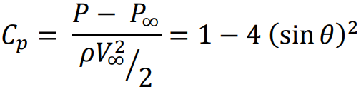The pressure distribution around the circular cylinder based on the ideal fluid flow theory is expressed by pressure coefficient Cp  given by:
* Near a solid boundary, the viscous force resists the pressure force and acceleration force up to a certain angle. But as the angle increases, the flow structure changes and both the viscous and pressure forces resist the acceleration force. Turbulent flow has more momentum, causing the boundary layer to separate further away than in laminar flow. Fluid particles overcome this resistance by converting pressure force into kinetic energy.

**RESULTS and GRAPHS:**

FROM THE LAB –

Smooth Cylinder

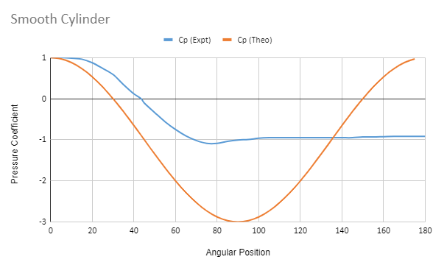

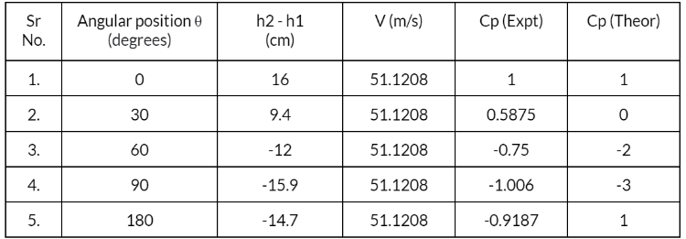

From Model –

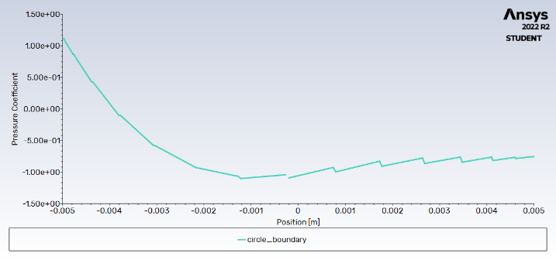

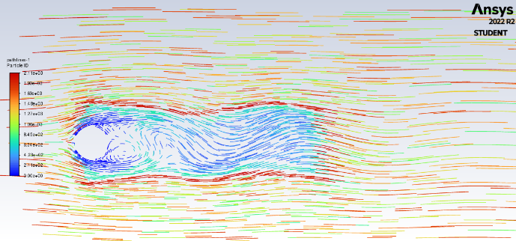

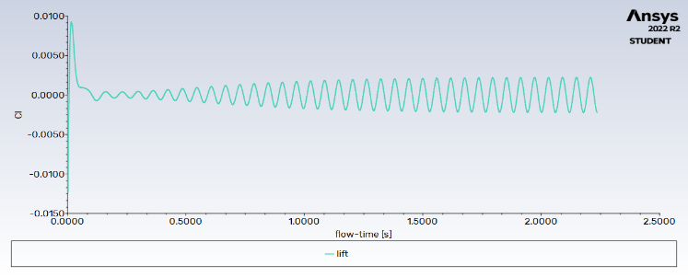Cp vs X curve where X = R*cos(Theta)

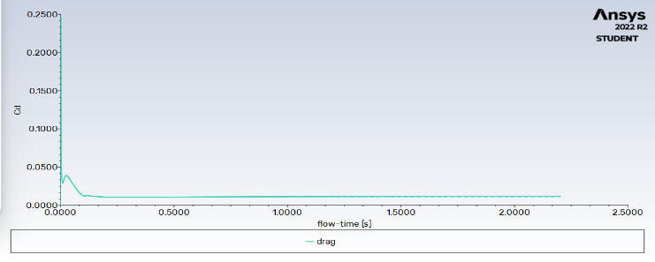

Lift Force Drag Force

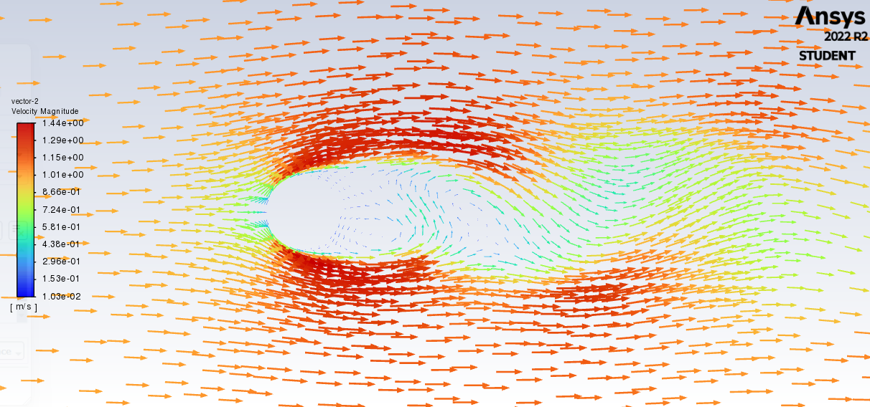

Velocity vectors coloured by Velocity Magnitude

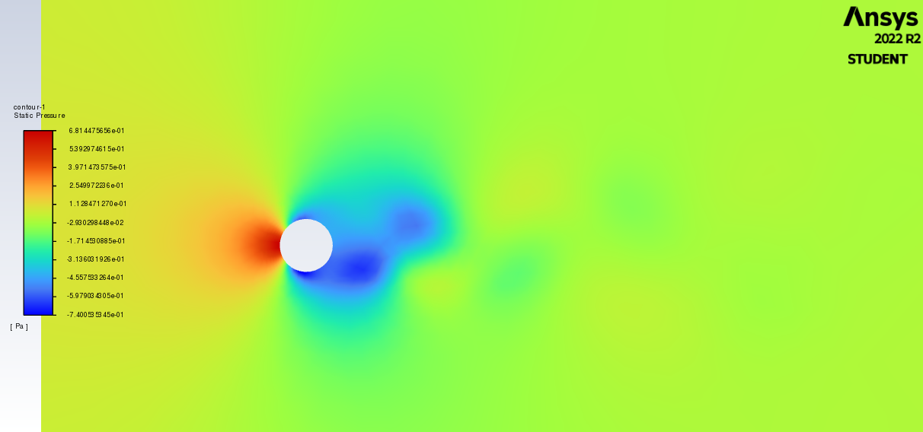

Contours of static pressure

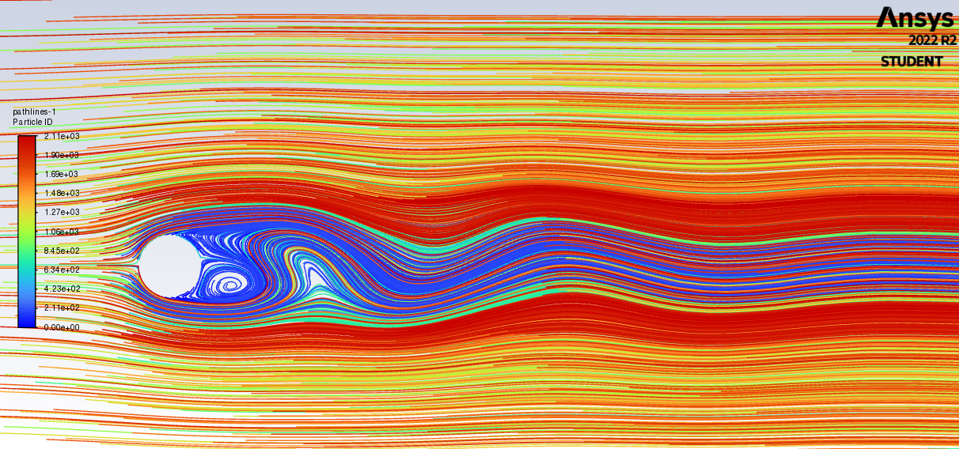

Pathlines colored by Particle ID

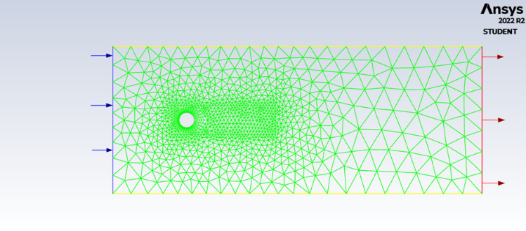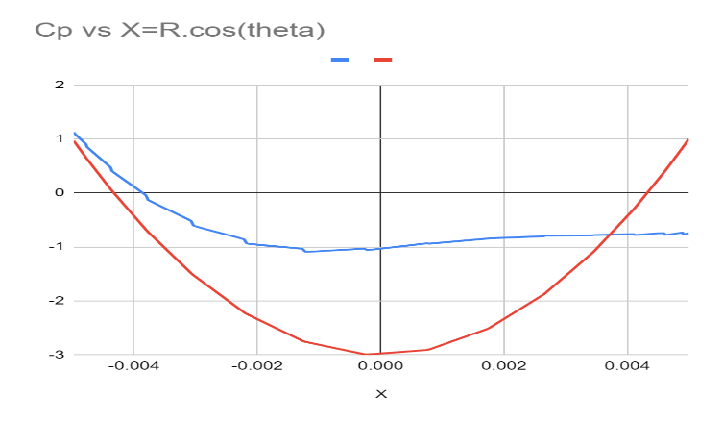

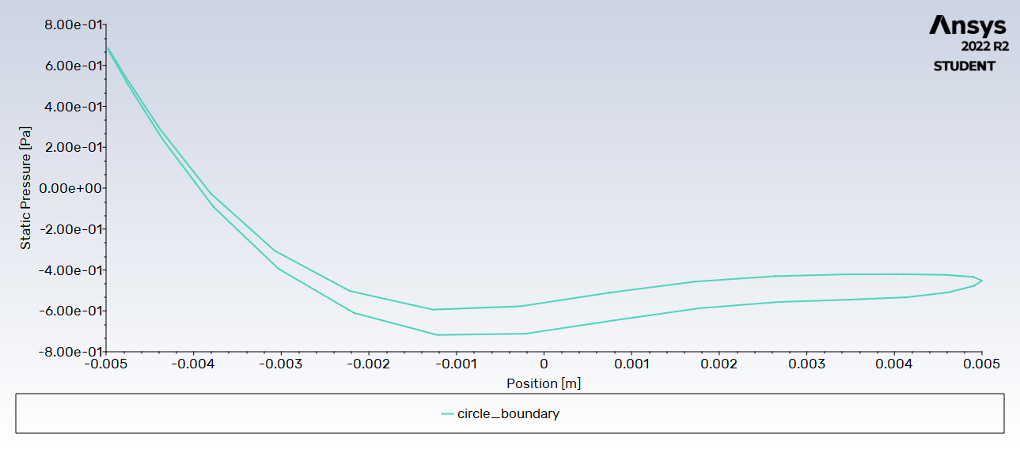 Static Pressure vs position X

**COMPARISON:**

* The Cp vs Angular position graph is almost exactly similar for both the stimulation and the lab

experiment.

* Both methods would provide data on the pressure distribution around the cylinder under certain flow conditions.
* Both methods would also provide insights into the flow behavior and characteristics around the cylinder, such as the formation of vortices and turbulence.
* In the ANSYS simulation, pressure values can be obtained at any given time step, whereas in the lab experiment, measurements are typically taken at discrete time intervals. This difference in time resolution could lead to differences in the pressure distribution results.

***REASON FOR DIFFERENCES***

* Measurement Accuracy
* Assumptions made in stimulation
* Boundary Conditions
* Mesh size and quality

***CONCLUSIONS:***

* The applied computational analysis of the flow around cylinder with ANSYS shows that obtained results keep closed to experimental.

* The results for pressure coefficient present some differences from the analytical formula, but they are more closed to experimental results.

* The accuracy of computational analysis could be improved further by meshing with higher density the entire domain of analysis and using more powerful hardware resources.

* Having experimented on the simplest possible case, we were able to obtain results close to theory. However complex shapes would have much more degrees of freedom, boundary influentials and interference of phenomenons. In that case, analysis can still be done by trying to define the shapes as simple ones where the variations are approximately linear.

Contribution :

Tanmay Jain(210100156) – Ansys Model Formation

Kavan Vavadiya (210100166) – Analysis and slide / Report writing

Mohammad Kadiri (210040142) – Ansys model , Slide